Software testing verification and validation

MIDTERM REPORT

|  |  |  |
| --- | --- | --- |
| Moustapha Sy Dieng  mxd152830 | Ponmalar Silambaram Chandrabose  pxs162030 | Trung Hieu Tran  txt171930 |

1. **The problem statement**

In 1970, Edsger W. Dijkstra said that “program testing can be used to show the presence of bugs, but never to show their absence” [1].

 In fact, it can be easily demonstrated that even achieving a hundred percent code coverage does not guarantee bug-free software. For this reason, we can’t effectively rely on code coverage as a metric for software quality. Our aim is to therefore utilize mutation testing to measure unit tests fiability. Mutation testing provides the ability to not only detect if code is executed but also evaluate the test suite ability to uncover regressions. It accomplishes this by introducing changes to the code, called mutations, and running the test suite against the newly modified code. In the next section, we will discuss some techniques used to implement it.

1. **The basics of existing techniques and/or the design of your technique**

**2.1 Overview of PIT Mutation Testing:**

Mutation testing is a concept where faults (or mutations) are automatically seeded into the code, tests are run and if any of the tests fail, then the mutation is killed. Otherwise the mutation lived. The percentage of mutations gauge the quality of the tests performed.

Specifically PIT Mutation Testing, an open source mutation testing tool  is selected. Here, PIT runs your unit test against versions of application code that have been automatically modified. When the tests are run, since the application code has been changed it should produce different results. If a unit test does not fail in this situation, then there is some problem in the test suite [2].

**2.2 Why use PIT?:**

PIT Mutation Testing is fast because it operates on bytecodes and optimizes the executions of mutants. It can also be integrated into a wide range of development tools and also invoked through command line interfaces like Ant or Maven.

**2.3 Existing Mutators:**

Some of the mutators that are already available in the PIT Mutation Testing include

Conditionals Boundary Mutator : They replace the relational operators

Increments Mutator : They mutate the increments, decrements and assignment increments and decrements of local variables

Math Mutator : Replaces binary arithmetic operations for either integer or floating -  point arithmetic

Invert Negatives Mutator : It inverts negation of integer and floating point numbers.

Return values mutator :  It mutates the return values of the method calls depending on the type

Void Method calls Mutator : It removes method calls to void methods

1. **Your implementation/study plan**

**Project Goals**

The goal of the project was to augment the PIT mutation testing tool by adding three additional mutators:

1. AOD (Arithmetic Operator Deletion): Replace an arithmetic expression by each one of the operand.
2. AOR (Arithmetic Operator Replacement): Replace an arithmetic expression by each of the other ones.
3. ROR (Relational Operator Replacement): Replace the relational operators with each of the other ones.

**Preparations**

Our first task was to setup our environment. We opted to use the following configuration:

* IDE: Eclipse Oxygen
* Java version: JDK 1.8
* Build system: Apache Maven 3.5.3
* Version control: GitHub

Once we setup the environment, we created a small program along with a couple of test cases to ensure we were able to run unit tests properly. (Figure 1)

Figure 1


Figure 1

Next, we cloned the pitest repository from Github. We ran into our first obstacle when attempting to run mutation testing on our program. We were mistakenly attempting to build the project we created with the command ‘mvn clean install’ command. After much troubleshooting, we figured out that the pitest project needed to be built in this manner. After successfully building the project, we were able to run the default pitest mutators on our program successfully.

**Strategy**

We decided to divide up the workload. Trung worked on implementing AOD, Ponmalar Silambaram Chandrabose took on AOR’s implementation and Moustapha handled ROR’s.

**AOD**

AOD replaces an arithmetic expression by each one of the operand. Below is the replacement table which is applied in the scope of the program.

|  |  |  |  |
| --- | --- | --- | --- |
| Operator | Expression sample | Replaced by the first operand | Replaced by the second operand |
| + | a + b | a | b |
| - | a - b |
| * | a * b |
| / | a / b |
| % | a % b |

First operand replacement

To replace an expression by the first operand, we had to remove the first parameter from the stack of java virtual machine which is associated the second operand in the expression. However, we needed to take into account the way JVM stores the different data types. Data types with sizes betweem 8-bits and 32-bits occupy 1 stack slot, while 64-bits data occupies 2 stack slots. Therefore, it would take 1 stack slot for *int* and *float* and this figure is 2 stack slots for *double* and *long.* Thus, we used the operand stack *POP* to remove item from the stack for *int* and *float* operators and the *POP2* for *double* and *long* operators*.* The code snippet in figure 3 shows the example of implementation for addition operator  
Second operand replacement

To replace an expression by the second operand, there are 2 scenarios. For the int and float operators, we use operand *SWAP* to swap two items on the stack. Then, the order of operand in the expression is changed and the problem becomes the replace the expression by the first operand. In case of long and double operators, there doesn’t exist any operand to swap first two slots with next two slots in the stack. So that we use *DUP2_X2* to duplicate the first two slots in the stack and push them after the 4-th slot in the stack. Then we use *POP2* two timesto pop first 4-slots on the top of the stack and the remainder is the second operand of the expression. Below is the code snippet for those above scenarios.

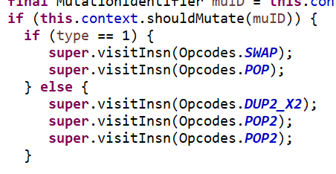

Figure 2

**AOR**

Definition

Arithmetic Operator Replacement is defined as the mutation process where one specific operator in an expression is replaced by all other operators.

For example: Let us consider a+b as an expression. This mutation operator should replace the ‘+’ operator by subtraction, multiplication, division and modulus operator.

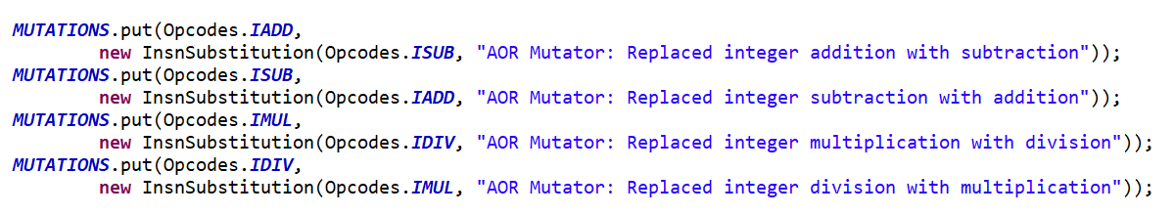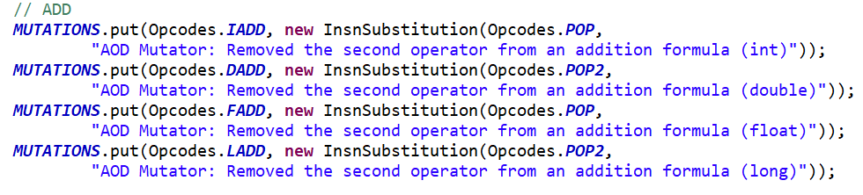

Figure 4

Figure 3

The possible combinations are:

|  |  |  |  |  |
| --- | --- | --- | --- | --- |
| + | - | * | / | % |
| - | * | / | % | + |
| * | / | % | + | - |
| / | % | + | - | * |
| % | + | - | * | / |

Thought Process

Solution 1:

We need to implement java byte code manipulation to replace these arithmetic operators in the byte code of the program directly.

We also need to take into consideration the various combinations of operator exchange possible in the system.

Solution 2: Manually go through the program and replace all of them, which becomes tedious if the program to be tested is really long.

Roadblocks:

Learning how to access the Java Byte code for that particular method.

Solution/Implementation

We took into consideration the data types such as integer, long, double and float for arithmetic operators because each of them are stored differently in the stack.

We also took into consideration the combinations of operators that can be replaced.

We used java byte code manipulation to replace these operators directly in the byte code of the program rather than change them manually in the system.

We used the MethodVisitor function to look through the system and visit every method in the program.

In each method we look for the ADD, SUB, MUL, DIV, REM functions for each respective data type represented in the byte code and replace them with each other using the put function in java

We maintain HashMap values of each of these and create separate functions for each combination possible to make it faster to implement the test function.

**ROR**

The implementation of the relational operator replacement required for each relational operator to be replaced by every other one. The table below shows the all the possible replacements we implemented (note: We only handled the cases listed on the project guideline):

|  |  |  |  |  |  |
| --- | --- | --- | --- | --- | --- |
| == | != | >= | > | <= | < |
| != | >= | > | <= | < | == |
| >= | > | <= | < | == | != |
| > | <= | < | == | != | >= |
| <= | < | == | != | >= | > |
| < | == | != | >= | > | <= |

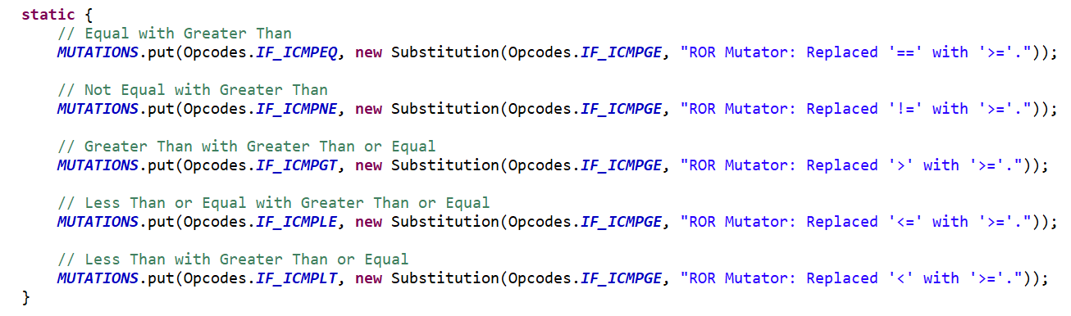Approach

Figure 5

We followed the same approach used by the existing mutators that perform similar replacement such as the Conditional

Boundary Mutator. We created a single mutator through an enum that implemented the MethodMutatorFactory which is responsible for creating the MethodVisitor method used to find mutation points and apply the mutators. Each method visitor extends AbstractJumpMutator since it contains the Substitution class which can replace one operator with another.

The flaw of this approach was that each mutator can only produce one mutant per mutation point. At first, we thought to change the way the mutations are stored by changing the map to a MultivaluedMap and the HashMap to a MultivaluedHashMap. However, that would require changing code outside the class we were creating.

Solution

We ended up creating a class containing several mutators defined through enums. We also defined method visitor for each of the cases we were going to handle. Figure 5 is a snippet of the method visitor responsible for replacing operators with the ‘>=’.

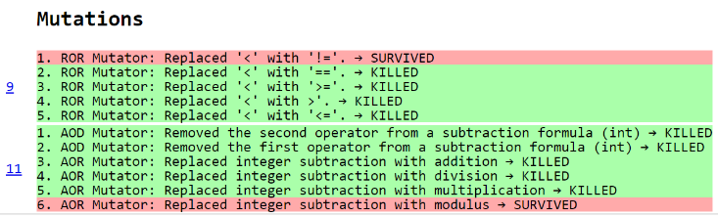In this manner, when each mutator is triggered, it changes the relational operator to the appropriate one as it visit the different method visitors. There are a total of six method visitors to handle the six separate cases.

Figure 6

**Results**

We first tested our mutators on the program we created.

**Future plans**

For the second phase, we are planning to implement the four mutators listed on the project guidelines and possibly some additional ones as time permits.

References:

[1]  E. W. Dijkstra, Notes On Structured Programming, Section 3 ("On The Reliability of Mechanisms"), 1970.

[2] <http://pitest.org/>